**Step 1: Downloading Tomcat**

1. Download Tomcat 9 from the link provided.

<https://tomcat.apache.org/download-90.cgi>

1. Click on Tomcat 9 link highlighted below in red.

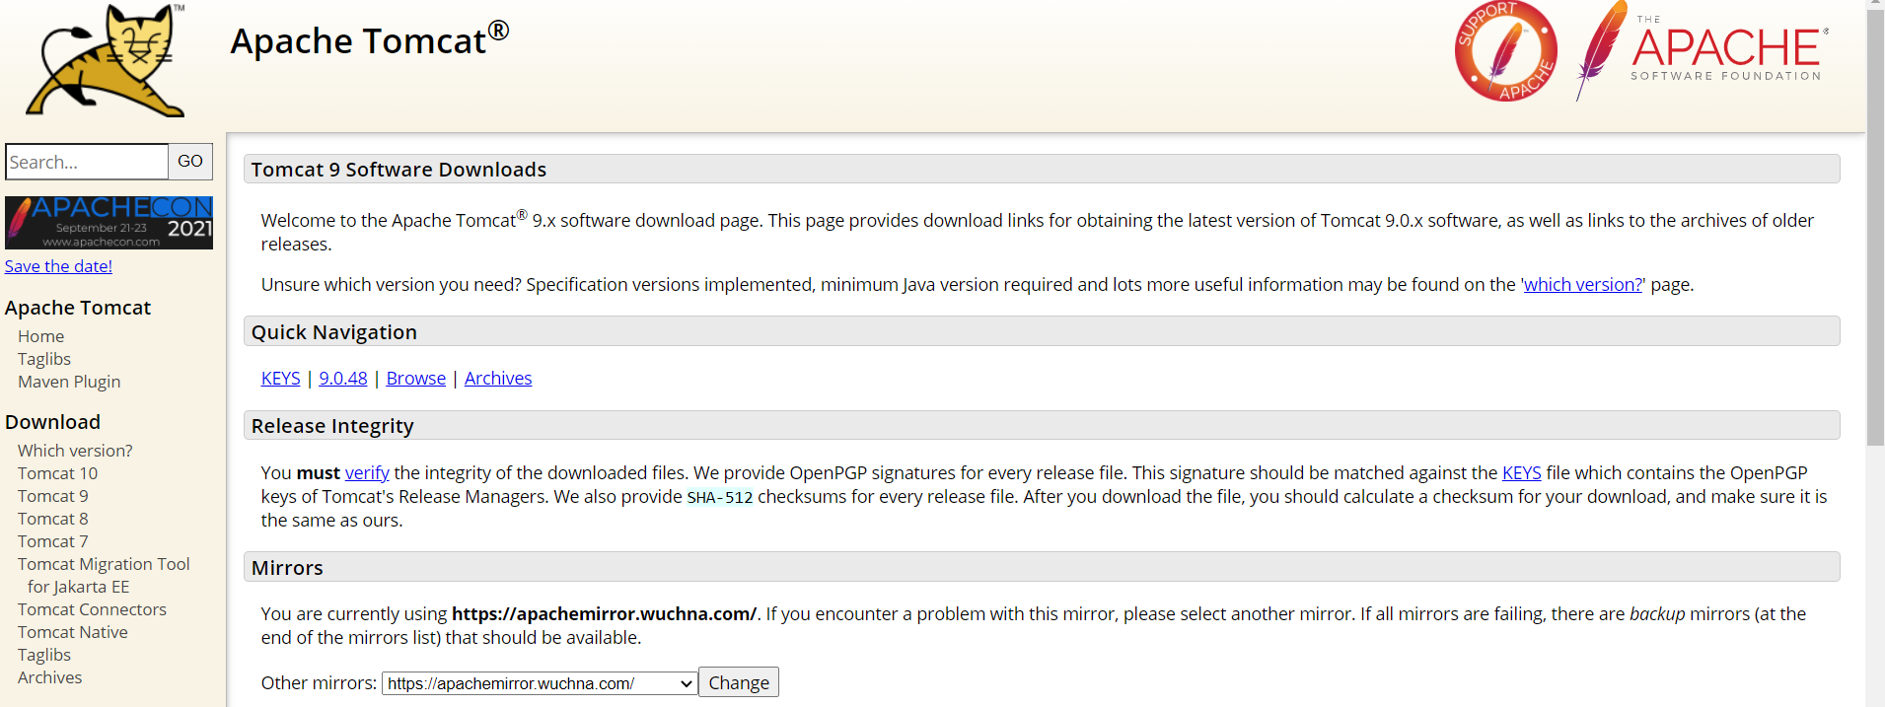

1. Scroll down the page and download the tomcat, which is relevant to your OS version.

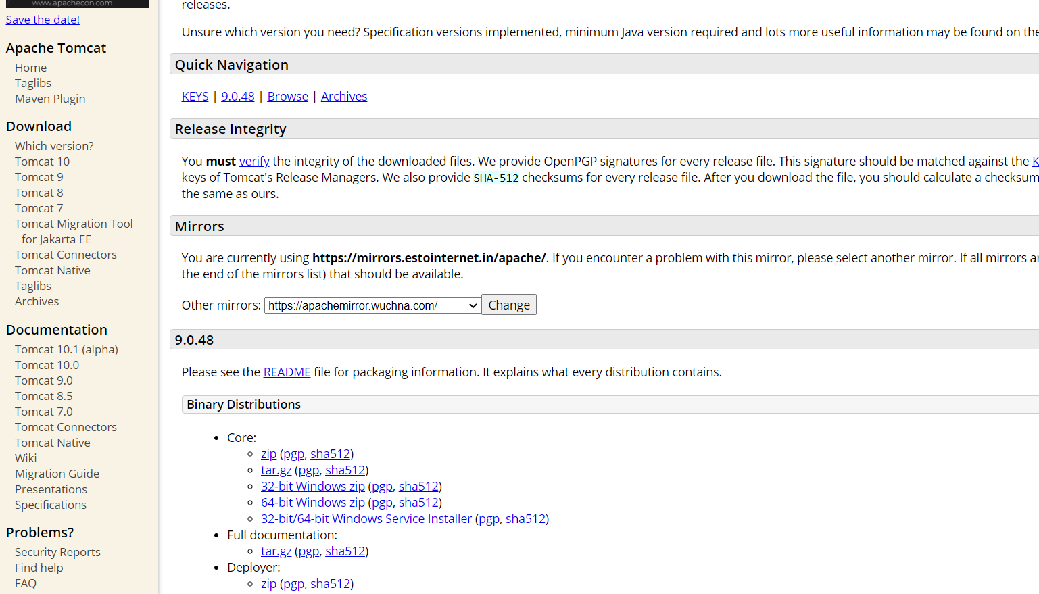

Pre requisite : java environment variables has to be set .

* Extract the zip file folder
* Paste the extracted folder (apache-tomcat-9.0.70) into users or program files
* **Setting environment variables**

user variables:

CATALINA_HOME : C:\Users\kavitha.m\apache-tomcat-9.0.70

system variables:

path: C:\Users\kavitha.m\apache-tomcat-9.0.70\bin

**For checking successful installation of Tomcat server**

goto command prompt:

To start the tomcat server :

>catalina.bat start

To stop the tomcat server

>catalina.bat stop

**Step 2: Adding the Smart Tomcat plugin in IntelliJ**

1. In IntelliJ IDE click on File->Settings.
2. Choose Plugins -> enter smart tomcat in search bar -> click on the Install button.

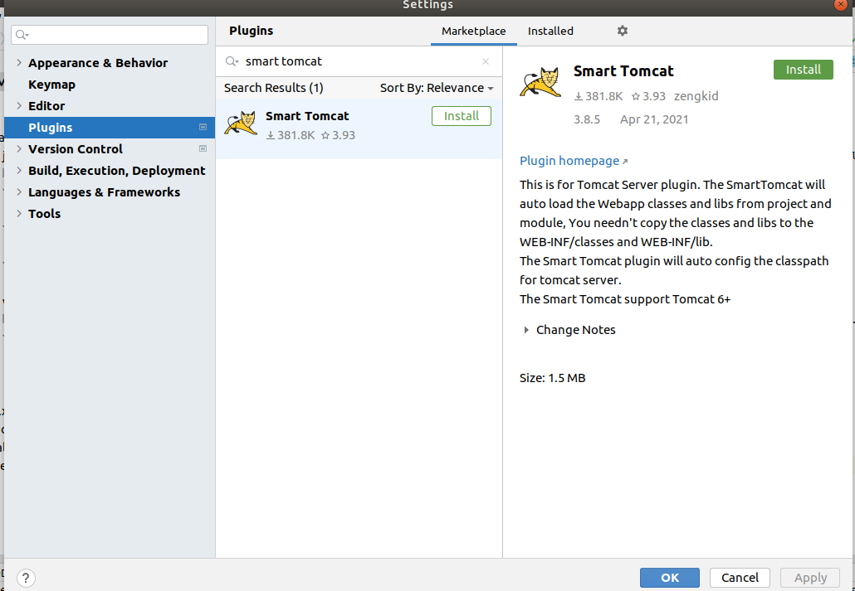

1. Once installed restart the IntelliJ IDE.
2. Go to File -> Settings ->Other Settings -> Tomcat Server -> click on + icon and give the path of the tomcat server installation.

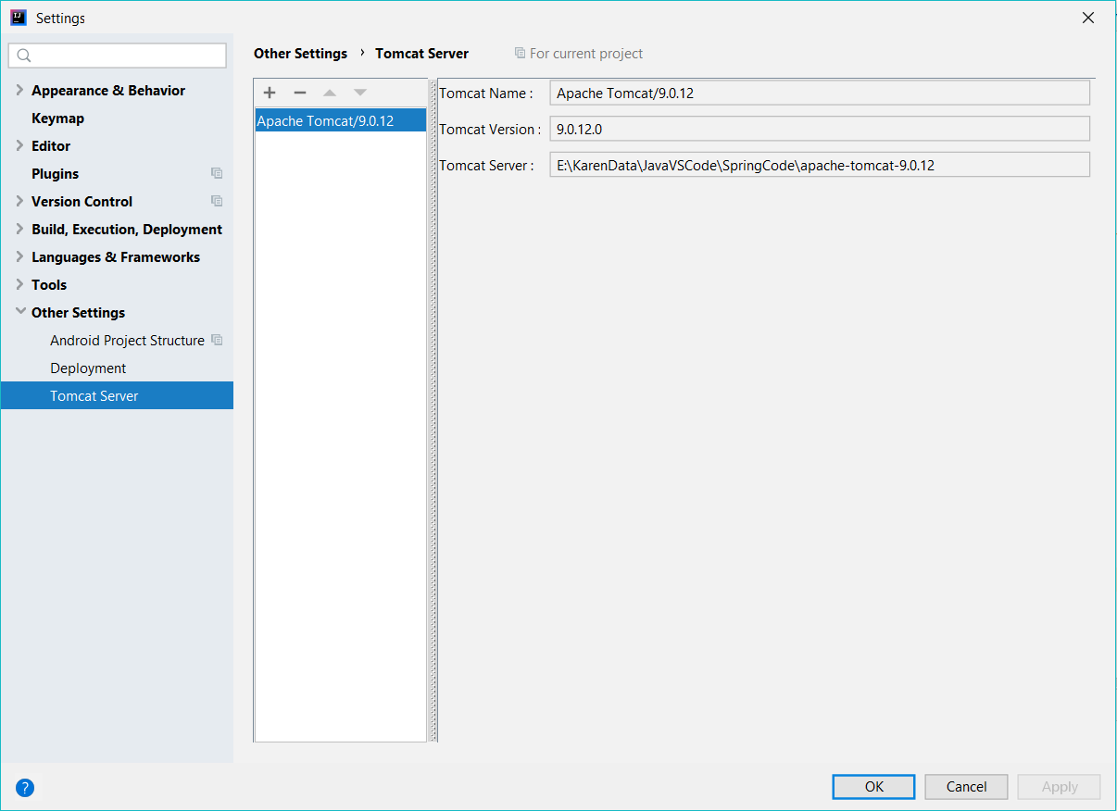

**Step 3: Build the WAR file**

1. Right click on the Project (MovieApplicationMVC) -> Open Module Settings.

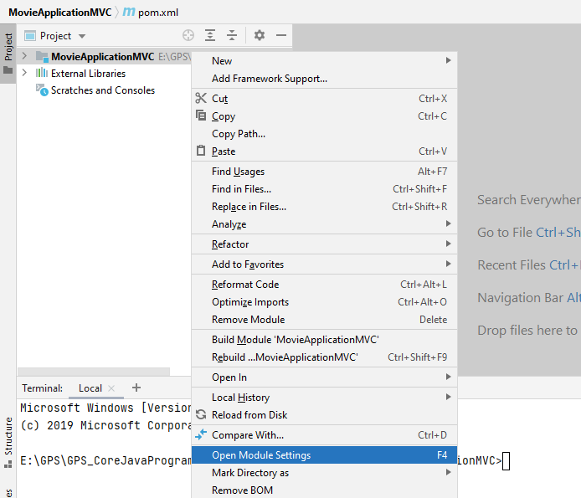

1. Goto the Artifacts and Build the War file for the project MovieApplicationMVC.

*Note : Name – MovieApplicationMVC.war must be typed manually*

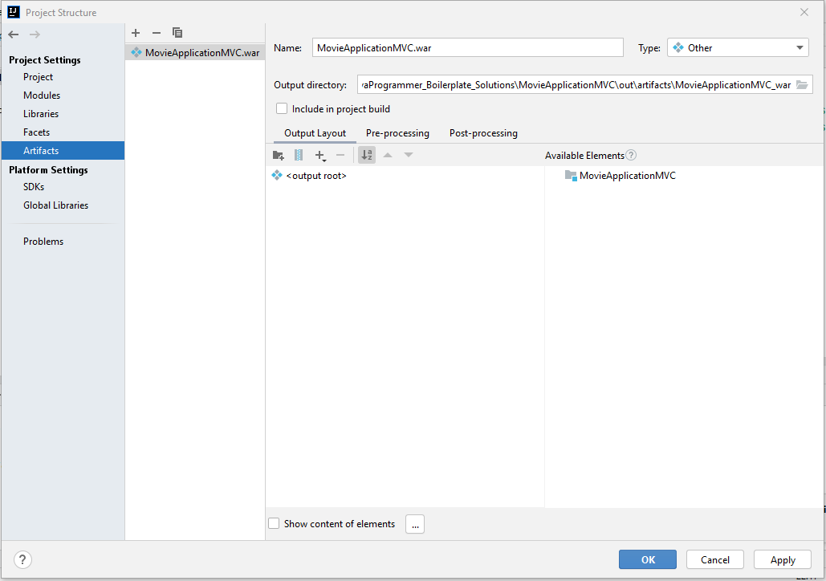

1. Click on the  icon shown on the screen and enter the war file name. MovieApplicationMVC.war

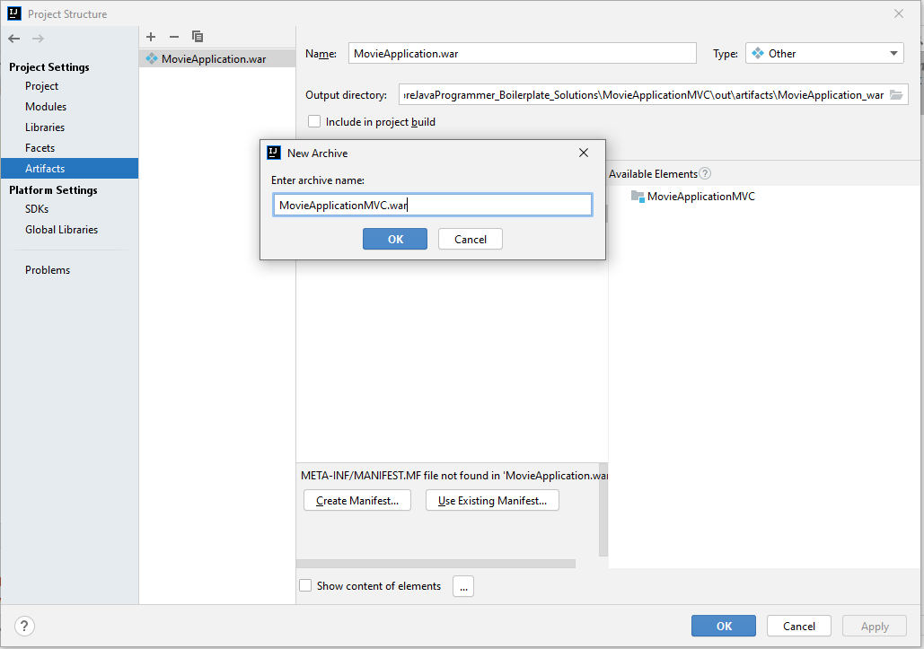

1. Now click on Apply and Ok. The WAR file is built for deploying on the server as shown below.

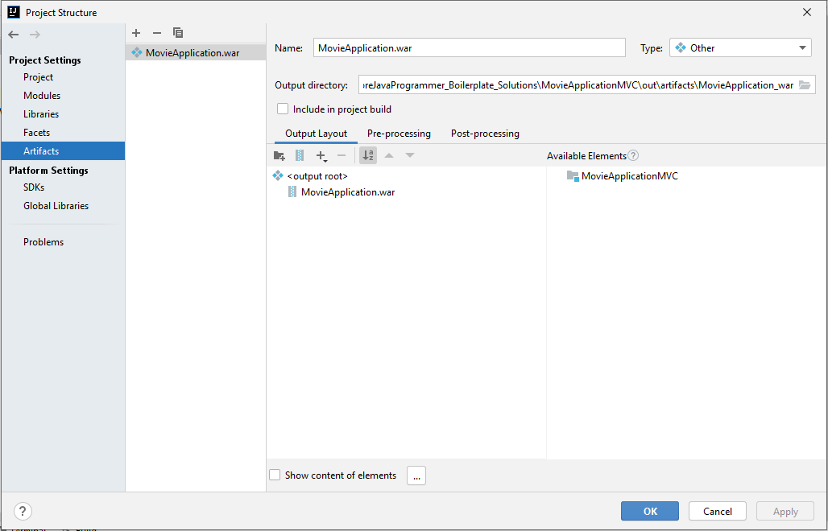

**Step 4: Deploy the WAR on the server**

1. Go to the Add Configurations highlighted in red below.

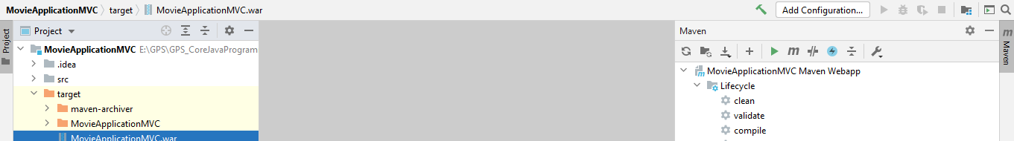

1. Add New Configuration for tomcat.

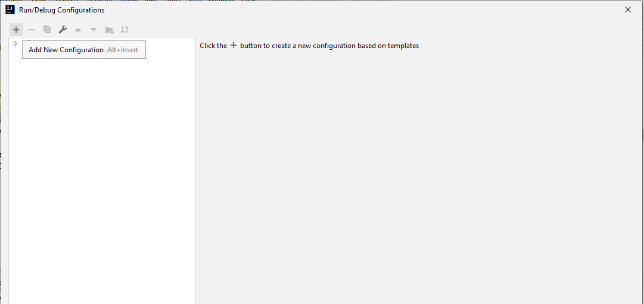

1. Add Smart Tomcat by clicking the + icon on the screen

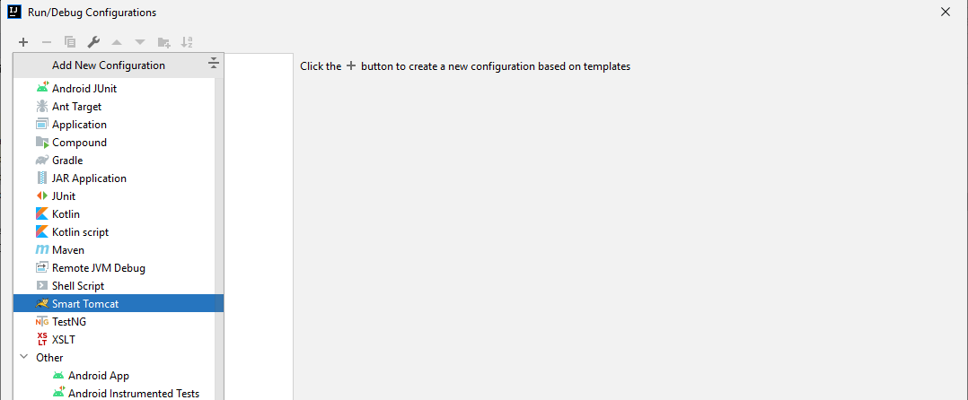

1. Add the configurations
2. Give a name to the tomcat server, in the below example the name given is **tomcat.**
3. The Deployment Directory must point to the webapp folder of the Project. If it does not appear by default, navigate to the webapp folder by clicking the folder icon.

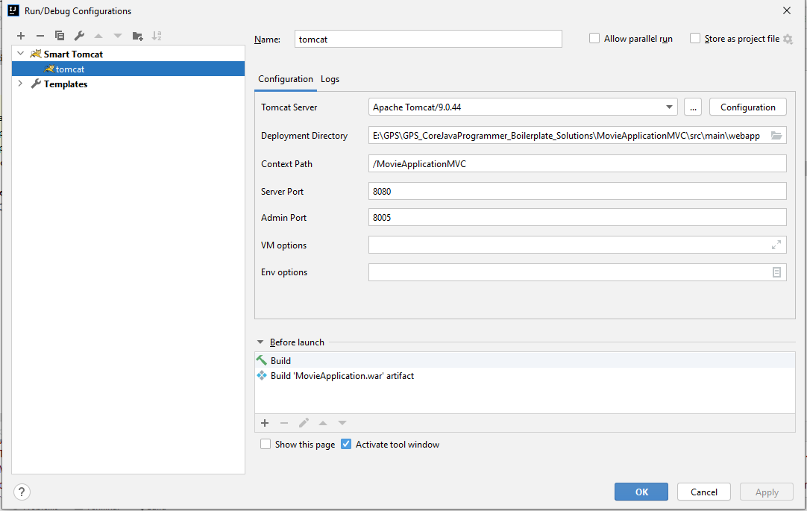

1. In Before launch section at the bottom of the screen click on the + icon (highlighted in red). 
2. Select the Build Artifacts option.

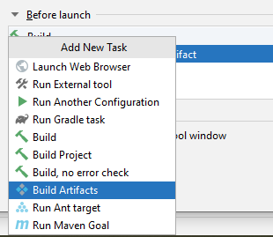

1. Select the artifact as the WAR file that we generated earlier. Click Apply and OK.

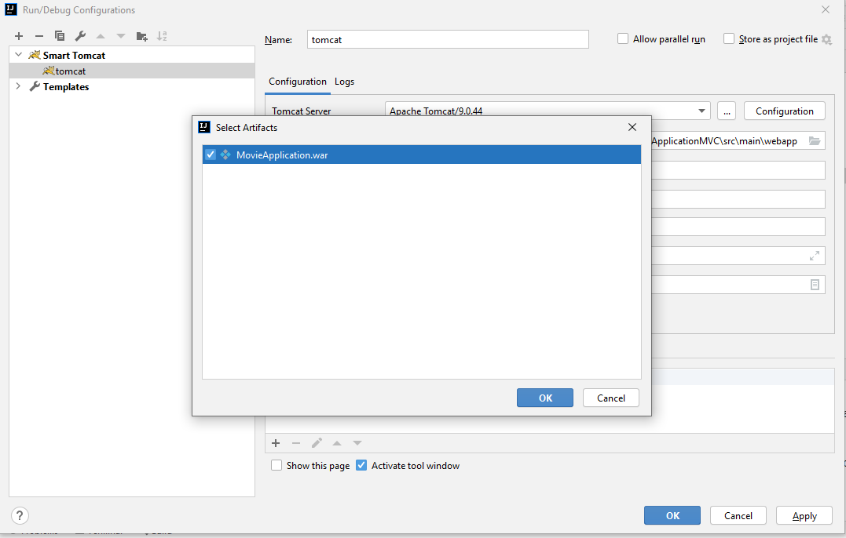

1. Now the project is ready to be deployed on the tomcat server.

**Step 5: Start the tomcat server**

1. Select the server and click run.



1. Open your browser and run the application at the 8080 port

<http://localhost:8080/MovieApplicationMVC>

*Note :*

1. *When you finish working with the application, before shutting down IntelliJ, make sure you stop the server.*
2. *The tomcat installation is done only for Spring MVC.*